Bahria University,

Karachi Campus



LAB EXPERIMENT NO.

**12**

LIST OF TASKS

|  |  |
| --- | --- |
| TASK NO | OBJECTIVE |
| **1** | **Write a Python program that implements golden section search method to find the max and min value of the following functions:**   * **𝑥2 + 2𝑥 ; −3 ≤ 𝑥 ≤ 5** * **0.5 − 𝑥 𝑒 −𝑥2 + 2𝑥 ; 0 ≤ 𝑥 ≤ 2** |
|  |  |
|  |  |

Submitted On:

**Date: 5/1/2024**

**Task No. 01:**

**Write a Python program that implements golden section search method to find the max and min value of the following functions:**

* **𝑥2 + 2𝑥 ; −3 ≤ 𝑥 ≤ 5**
* **0.5 − 𝑥 𝑒 −𝑥2 + 2𝑥 ; 0 ≤ 𝑥 ≤ 2**

**Solution:**

**Part A:**

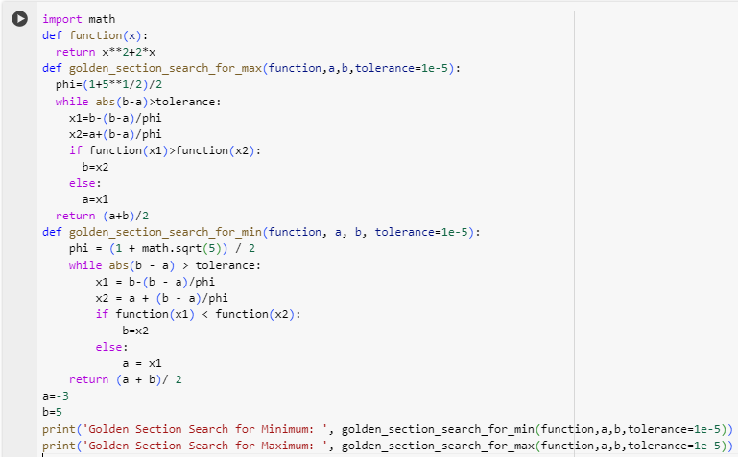 

**Part B:**

